**TODO List application:**

Application has few modules and which will have Home, todo list and logout.

The frameworks used are as follows:

1. Spring boot 2x
2. Spring data JPA
3. Spring Security with UserDetailsService implementation.
4. In memory H2 database
5. Embedded tomcat with jar file enabled.
6. For UI used HTML & JSP

**Spring Security:** I have used spring’s user service implementation and so that instead of hard coding the user details in the code, the data will be coming from the database. And after checking the username is present in the database, we are encoding the password and building the user details object using **builder design pattern**.

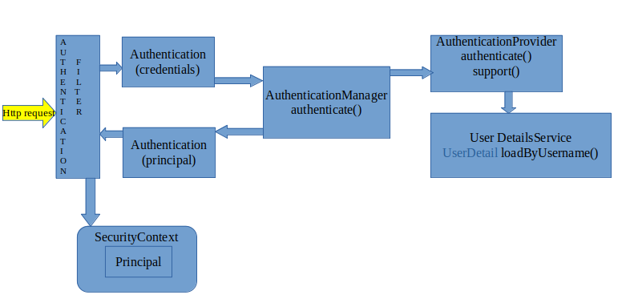

**Spring data JPA:** Used annotations to create and update the tables and also implemented one-to-many association for the users and todos table.

**Steps to run the application:**

Provided the jar file along with the source. Open command prompt where the jar file is available and use ‘java -jar todo-service-spring-boot-0.0.1-SNAPSHOT.war’

Application will be running on the port number 8081.

Link: <http://localhost:8081/>

Initial username and password is:

Username: admin

Password: admin